Hope Centre Food Bank

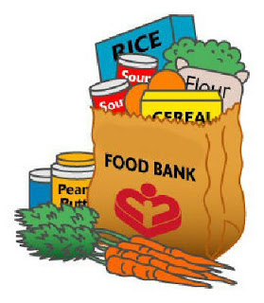
Every year, the families at Calvin Christian Elementary donate food items for the Hope Centre Emergency Food Bank. This is the time of year that they find their supplies running low and garden supplies are basically finished. Would you help us to help others by donating some food items? The following is a list of the most wanted items:
- Canned fish or poultry
- Baby food and formula
- Canned vegetables and fruit
- Canned stew, chili, brown beans
- Peanut butter
- Canned soup
- Cereal
- Canned spaghetti sauce
- Dry pasta and rice
Items should be brought to the school by the end of the day on October 8th.

